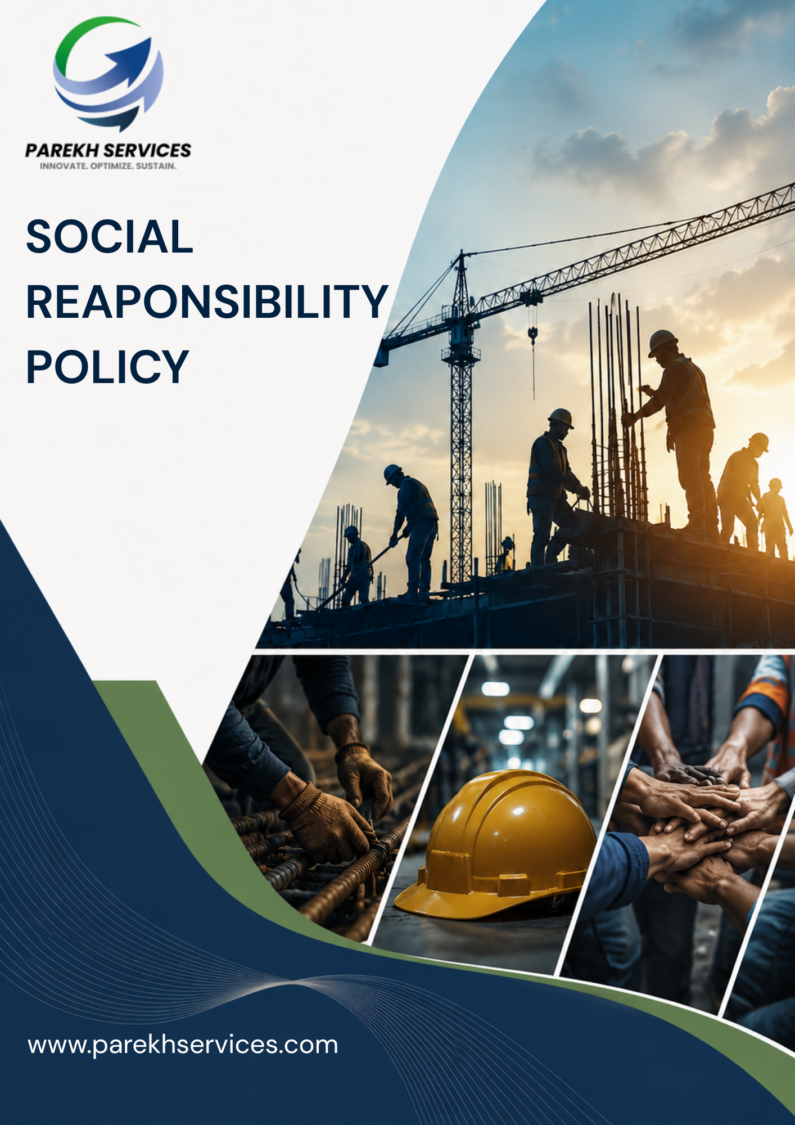
Contents

Introduction 3
Scope 3
Purpose 4
Key Focus Areas 4
Policy Commitments 4
Targets 8
SDGs Covered 10
Roles & Responsibilities 10
Reporting 12
Continuous Improvement 13
Review Mechanism 13
Acknowledgement 14

Introduction
PEWSPL is committed to maintaining a workplace that respects human rights, promotes fair labour practices, and provides equal opportunity, dignity, and respect to all employees and stakeholders. The Company believes that ethical employment practices, safe working conditions, diversity, inclusion, and employee well-being are essential for sustainable business growth and responsible business conduct.
PEWSPL is committed to complying with applicable labour laws, human rights principles, and employment regulations across all its operations. The Company strives to prevent discrimination, harassment, child labour, forced labour, and any form of unfair treatment while promoting a safe, inclusive, and respectful work environment.

Scope
This policy applies to all operations of PEWSPL, including transportation activities, operational facilities, warehouses, and office locations across all locations where PEWSPL operates. It covers all permanent, temporary, and contractual employees across all functions, as well as all internal and external stakeholders associated with PEWSPL, whether directly or indirectly engaged with the organization’s operations and services.
Sr. No. | Name of Operational Unit | (Corporate / Warehouse) | Registered Address of the Unit
1 | HO | Corporate | Parekh Ecom & Warehousing Services Pvt. Ltd., C/o Parekh Prints, 1st Floor, Italian Textile Compound, ITT Bhatti, Off Goregaon Mulund Link Road, Goregaon (E), Mumbai - 400 063
2 | Shakambari | Warehouse | Shakambari Logistic Park-Unit #A-1Premises # 1 to 7  Next to All Saint High School,  Pise Pipeline Road, Village Lonad  Tal-Bhiwandi - Thane, Maharashtra – 421302
3 | Lonikand | Warehouse | Parekh E-com & warehousing services Pvt. Ltd.  Chondhe Warehouse, Vadhu Khurd, Gate no-128/142/144,  Lonikand, Tal-Haveli, Dist-Pune Pin code- 412216, Maharashtra, India.
4 | Chakan | Warehouse | Gut No. 318/02, (P), Village-Kuruli, Tal. Khed, Dist.-Pune, 410501

Purpose
The purpose of this policy is to identify, assess, and manage human rights that impacts our business activities in the operational context, our leverage and business relationships. It aims to enhance the knowledge and understanding of human rights, foster attitudes of tolerance, respect, solidarity, and responsibility amongst PEWSPL employees. The policy aims to:
- Promote fair labour practices and responsible employment conditions.
- Ensure compliance with applicable labour laws and human rights requirements.
- Prevent child labour, forced labour, discrimination, harassment, and unfair treatment.
- Promote equal opportunity, diversity, inclusion, and workplace dignity.
- Maintain safe, healthy, and respectful working conditions.
- Encourage employee well-being, engagement, and ethical workplace behaviour.
- Foster awareness and accountability regarding labour rights and workplace conduct.

Key Focus Areas
PEWSPL shall focus on the following key human rights and labour management areas:
- Promote safe, hygienic, and healthy working conditions across all operations.
- Ensure fair employment practices, responsible working hours, wages, leave, and workplace conditions.
- Promote employee well-being, dignity, inclusion, work-life balance, and responsible workplace practices.
- Maintain a workplace free from discrimination, harassment, bullying, abuse, and unfair treatment.
- Support employee learning, skill development, awareness programs, and professional growth opportunities.
- Encourage transparent communication, employee engagement, grievance reporting, and respectful workplace interactions.
- Strictly prohibit child labour, forced labour, bonded labour, and all forms of human trafficking.

Policy Commitments
- Workplace Health, Safety & Operational Well-Being
- We are committed to maintaining safe, hygienic, and healthy working conditions across warehouses, transportation activities, and office facilities.
- We aim to minimize workplace risks and unsafe practices through responsible operational controls and safety procedures.
- We strive to strengthen employee awareness regarding workplace safety, emergency preparedness, and responsible operational behaviour.
- We are committed to promoting safe material handling, warehouse operations, and transportation practices across all applicable functions.
- We seek to support employee well-being through safe working environments and responsible workplace practices.
- We strive to strengthen workplace health and safety management practices in alignment with applicable ISO 45001 Occupational Health & Safety Management System requirements.
- We aim to conduct timely safety awareness initiatives and emergency response preparedness programs to support employees in identifying and managing workplace risks.
- We are committed to maintaining a workplace free from unsafe behaviour, violence, substance abuse, and practices that may negatively impact the workplace environment.
- Human Rights Protection & Ethical Employment
- We are committed to strictly prohibiting child labour, forced labour, bonded labour, and all forms of human trafficking across our operations.
- We aim to ensure compliance with applicable labour laws, minimum age requirements, and ethical employment practices.
- We strive to maintain responsible recruitment, employment verification, and workforce management procedures.
- We are committed to promoting awareness regarding ethical labour practices and responsible employment standards.
- We will encourage responsible labour practices across contractors, manpower providers, and business partners associated with the Company.
- We are committed to maintaining a zero-tolerance approach towards modern slavery and human trafficking across our operations and supply chain relationships.
- We strive to ensure that employees work voluntarily and are free to terminate employment in accordance with applicable employment conditions and legal requirements.
- Employee Communication & Grievance Management
- We are committed to promoting transparent communication and respectful workplace interactions across the organization.
- We aim to encourage employees to report workplace concerns, grievances, or operational issues through appropriate reporting channels.
- We strive to maintain fair, transparent, and confidential grievance handling mechanisms.
- We are committed to promoting employee participation and engagement in workplace improvement initiatives wherever feasible.
- We aim to foster a workplace culture based on mutual respect, collaboration, and responsible communication.
- We are committed to fostering positive employee relations through open communication, employee engagement, and constructive interaction with workforce representatives.
- We strive to create workplaces in which open and honest communication among employees is encouraged and respected.
- We are committed to ensuring that employees can raise workplace concerns without fear of retaliation or unfair treatment.
- Training, Skill Development & Career Growth
- We are committed to supporting employee learning, skill development, and professional growth opportunities.
- We aim to strengthen employee capabilities through operational, safety, behavioural, and policy awareness training programs.
- We strive to promote continuous learning and responsible workplace behaviour across all operational functions.
- We are committed to encouraging employee participation in training and awareness initiatives relevant to their roles and responsibilities.
- We seek to support workforce competency and operational efficiency through regular capability-building initiatives.
- We strive to continuously develop and integrate relevant workplace awareness and human rights topics into employee training programs.
- We are committed to promoting awareness regarding ethical conduct, labour rights, and responsible workplace practices across the organization.
- Fair Employment Practices & Responsible Working Conditions
- We are committed to maintaining fair and responsible working conditions across all business operations.
- We aim to ensure compliance with applicable labour laws relating to wages, working hours, leave, and employee benefits.
- We strive to promote ethical employment practices and respectful workplace behaviour across all levels of the organization.
- We are committed to maintaining transparent employment practices and responsible workforce management procedures.
- We will support a positive and professional work environment that promotes employee dignity and respect.
- We are committed to promoting work-life balance and responsible workplace practices wherever operationally feasible.
- We strive to maintain open and direct communication with employees regarding workplace concerns, employment conditions, and employee rights.
- Inclusive Workplace & Anti-Harassment Practices
- We are committed to maintaining a workplace free from discrimination, harassment, bullying, abuse, intimidation, or unfair treatment.
- We aim to promote equal opportunity, dignity, inclusion, and mutual respect across all levels of the organization.
- We strive to encourage respectful workplace behaviour and responsible professional conduct.
- We are committed to maintaining fair and transparent processes for reporting and addressing workplace concerns.
- We aim to strengthen employee awareness regarding workplace behaviour, inclusion, and anti-harassment practices.
- We strive to maintain an inclusive work culture in which employees feel respected, valued, and supported in their professional growth.
- We are committed to promoting equal opportunity in recruitment, training, development, compensation, and career advancement based on qualifications, skills, and performance.
- Employee Welfare, Inclusion & Well-Being
- We are committed to promoting employee well-being and responsible workplace welfare practices across all operations.
- We aim to support a positive, inclusive, and respectful work environment for employees.
- We strive to encourage employee engagement, work-life balance, and responsible workplace interactions wherever feasible.
- We are committed to supporting employee welfare initiatives and awareness programs across operational facilities.
- We seek to promote employee morale, dignity, and overall workplace well-being through responsible management practices.
- We strive to support employee well-being through responsible workplace practices, access to basic welfare facilities, and healthy workplace environments.
- We are committed to encouraging workplace practices that support employee health, hygiene, and general well-being across operations.

Targets
- Workplace Health, Safety & Operational Well-Being
- We aim to provide annual health and safety awareness training to at least 85% of employees by FY 2029–30 from the FY 2022–23 baseline.
- We aim to maintain achieve 100% periodic safety inspections across major operational locations by FY 2029–30 from the FY 2022-23 baseline.
- We are committed to improving closure of identified workplace safety observations by 80% by FY 2029–30 from the FY 2022–23 baseline.
- We strive to increase availability of workplace safety communication and signage across 100% of operational sites by FY 2029–30 from the baseline FY 2022-23.
- We aim to improve compliance with applicable ISO 45001 occupational health and safety management requirements across major operational locations by 80% from the FY 2022–23 baseline by FY 2029–30.
- We aim to increase employee healthcare coverage and access to medical welfare benefits to at least 70% of employees by FY 2029-30 from the FY 2022-23 baseline.
- We aim to improve availability of first-aid and emergency response facilities across 100% of major operational locations by FY 2029–30 from the baseline FY 2022-23.
- We strive to increase periodic health and wellness awareness communication to employees by 80% by FY 2029–30 from the FY 2022–23 baseline.
- Human Rights Protection & Ethical Employment
- We strive to improve supplier and contractor participation in ethical labor awareness initiatives to at least 75% by FY 2029–30 from the FY 2022–23 baseline.
- We aim to communicate responsible labor and human rights requirements to 100% of major suppliers and contractors by FY 2029–30 from the baseline FY 2022-23.
- We strive to improve employee and contractor awareness regarding ethical labor practices to at least 90% by FY 2029–30 from the FY 2022–23 baseline.
- We aim to include responsible labor practice clauses in at least 90% of applicable supplier and contractor agreements by FY 2029–30 from the baseline FY 2022-23.
- We aim to improve monitoring of labor-related compliance documentation by 85% by FY 2029–30 from the FY 2022–23 baseline.
- Employee Communication & Grievance Management
- We strive to maintain 100 % documented employee feedback review practices across all departments by FY 2029–30 from the baseline FY 2022-23.
- We aim to improve employee participation in internal communication initiatives to at least 80% by FY 2029–30 from the FY 2022–23 baseline.
- We aim to conduct at least four employee engagement and communication sessions annually by FY 2029–30 from the baseline FY 2022-23.
- We aim to maintain 100% coverage of all the employees under applicable employee representation, consultation and collective engagement frameworks by FY 2030 from the baseline FY 2022-23.
- We strive to improve employee awareness regarding grievance and feedback mechanisms to at least 90% by FY 2029–30 from the FY 2022–23 baseline.
- Training, Skill Development & Career Growth
- We aim to improve employee participation in internal communication initiatives to at least 80% by FY 2029–30 from the FY 2022–23 baseline.
- We aim to provide annual training and skill development programs to at least 85% of employees by FY 2029–30 from the FY 2022–23 baseline.
- We strive to conduct a minimum of 3 internal learning and awareness sessions annually by FY 2029–30 from the baseline FY 2022-23.
- We are committed to improving employee participation in performance and development review processes to at least 90% by FY 2029–30 from the baseline FY 2022-23.
- We aim to increase role-based and technical training coverage by 75% by FY 2029–30 from the FY 2022–23 baseline.
- We strive to maintain training communication and documentation practices across 100% of departments by FY 2029–30 from the baseline FY 2022-23.
- Fair Employment Practices & Responsible Working Conditions
- We strive to increase employee awareness regarding workplace welfare facilities to at least 85% by FY 2029–30 from the FY 2022–23 baseline.
- We are committed to strengthening workplace cleanliness and operational housekeeping practices across 100% of major locations by FY 2029–30 from the baseline FY 2022-23.
- We aim to maintain 100% compliance with applicable statutory inspection, employee welfare, and operational requirements under the Factories Act, 1948 wherever applicable to Company operations by FY 2029–30 from the baseline FY 2022-23.
- We aim to improve workplace facility assessment coverage across all major operational locations to 100% by FY 2029–30 from the baseline FY 2022-23.
- We strive to increase employee awareness regarding workplace policies and code of conduct to at least 90% by FY 2029–30 from the FY 2022–23 baseline.
- We are committed to implementing workplace improvement initiatives across at least 80% of identified areas by FY 2029–30 from the baseline FY 2022-23.
- Inclusive Workplace & Anti-Harassment Practices
- We aim to improve communication of equal opportunity and workplace respect practices across 100% of employees by FY 2029–30 from the baseline FY 2022-23.
- We are committed to strengthening employee awareness regarding ethical workplace practices to at least 90% by FY 2029–30 from the FY 2022–23 baseline.
- We aim to provide workplace ethics, anti-discrimination, and anti-harassment awareness training to at least 90% of employees by FY 2029–30 from the baseline FY 2022-23.
- We strive to improve employee awareness regarding grievance reporting and redressal mechanisms to at least 95% by FY 2029–30 from the FY 2022–23 baseline.
- We strive to improve employee participation in workplace inclusion and ethics initiatives by 80% by FY 2029–30 from the FY 2022–23 baseline.
- We aim to strengthen policy communication coverage related to workplace conduct and inclusion across 100% of employees by FY 2029–30 from the baseline Fy 2022-23.
- Employee Welfare, Inclusion & Well-Being
- We aim to improve employee participation in workplace wellness communication initiatives to at least 80% by FY 2029–30 from the FY 2022–23 baseline.
- We are committed to enhancing awareness regarding employee support and welfare initiatives across 100% of operational facilities by FY 2029–30 from the baseline FY 2022-23.
- We aim to increase employee participation in wellness and well-being initiatives to at least 80% by FY 2029–30 from the FY 2022–23 baseline.
- We aim to strengthen communication related to employee wellness and inclusion initiatives across 100% of major operational locations by FY 2029–30 from the baseline FY 2022-23.
- We strive to improve employee participation in feedback and satisfaction initiatives by 75% by FY 2029-30 from the FY 2022–23 baseline.
- We are committed to improving employee awareness regarding welfare and support programs to at least 90% by FY 2029–30 from the baseline FY 2022-23.

SDGs Covered
 |  |  | 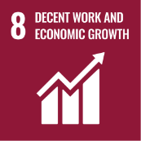 | 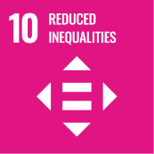 | 

Roles & Responsibilities
- Top Management
- Provide strategic direction and leadership on labour rights, human rights, ethical employment practices, and employee well-being across all operations.
- Approve the Human Rights and Fair Labour Practices Policy, objectives, and improvement initiatives.
- Ensure availability of adequate resources for implementation of fair labour and human rights commitments.
- Promote a culture of dignity, equality, inclusion, respect, and non-discrimination across the organization.
- Periodically review labour practices, employee welfare initiatives, and compliance performance.
- Human Resources (HR) Department
- Review this policy regularly.
- Implement and maintain fair labour and human rights practices across all business operations.
- Ensure compliance with applicable labour laws, wage regulations, working hour requirements, and statutory obligations.
- Monitor recruitment, onboarding, compensation, benefits, leave, and disciplinary processes to ensure fairness and transparency.
- Ensure prevention of child labour, forced labour, harassment, abuse, discrimination, and retaliation in the workplace.
- Promote equal opportunity, diversity, inclusion, and respectful workplace practices.
- Conduct employee awareness, induction, and training programs on labour rights, workplace behaviour, ethics, and grievance mechanisms.
- Maintain confidential grievance reporting and employee communication channels.
- Support periodic assessments, audits, and corrective actions related to labour and human rights practices.
- Operations and Department Heads
- Ensure implementation of fair labour practices and respectful workplace behaviour within their respective functions and operational locations.
- Monitor working conditions, workload distribution, employee conduct, and workplace safety practices.
- Ensure employees, contract workers, and third-party personnel are treated fairly and respectfully.
- Prevent discrimination, harassment, abusive behaviour, and unfair employment practices within operational areas.
- Support employee welfare, engagement, and grievance resolution initiatives.
- Immediately report any labour rights concerns, non-compliance issues, or unethical practices to HR or management.
- Managers and Supervisors
- Maintain a safe, respectful, and inclusive work environment.
- Ensure fair treatment of employees and workers under their supervision.
- Promote equal opportunity and non-discriminatory workplace practices.
- Address employee concerns professionally, confidentially, and without retaliation.
- Encourage employee participation, communication, and workplace collaboration.
- Support implementation of employee welfare and engagement initiatives.
- Employees
- Treat colleagues, customers, contractors, and stakeholders with dignity, fairness, and respect.
- Follow Company policies related to workplace behaviour, ethics, human rights, diversity, and labour practices.
- Refrain from discrimination, harassment, intimidation, abusive conduct, or unethical behaviour.
- Promptly report workplace concerns, misconduct, harassment, unsafe conditions, or labour rights violations through designated channels.
- Participate in awareness programs, training sessions, and workplace improvement initiatives.
- Support a positive, respectful, and inclusive workplace culture.
- Contractors, Suppliers, and Business Partners
- Comply with applicable labour laws, human rights standards, and Company requirements while working with PEWSPL.
- Prohibit child labour, forced labour, bonded labour, discrimination, harassment, and abusive workplace practices.
- Ensure fair wages, lawful working hours, safe working conditions, and respectful treatment of workers.
- Support ethical employment practices and responsible business conduct across the supply chain.
- Cooperate with PEWSPL in assessments, audits, investigations, or corrective action initiatives related to labour and human rights compliance.

Reporting
Implementation of this Social Responsibility Policy shall be monitored through periodic reviews, employee feedback, workplace inspections, compliance assessments, and grievance management mechanisms. Labour-related concerns, incidents, and corrective actions shall be tracked and reviewed regularly.

Continuous Improvement
PEWSPL is committed to continually improving labour and human rights practices through regular review of workplace standards, employee awareness initiatives, grievance mechanisms, and compliance processes. The Company will continue strengthening fair employment practices, employee well-being, and workplace culture in line with legal requirements and responsible business commitments.

Review Mechanism
This Social Responsibility Policy shall be reviewed annually by the Human Resources Department or whenever significant changes occur in labour laws, operational activities, workforce structure, stakeholder expectations, or organizational requirements, to ensure its continued relevance, effectiveness, and alignment with the Company’s human rights and fair labour commitments.

Effective Date: 01-04-2025
Last Review Date: 01-01-2026
Next Review Date: 01-01-2027
Rev.No: 1.0

Approved By:
Human Resources (HR PEWSPL)

Acknowledgement
I, the undersigned, acknowledge that I have received, read, and understood the Social Responsibility Policy of Parekh e-Com and Warehousing Services Private Limited.
I understand the Company’s commitment to ethical employment practices, equal opportunity, fair treatment, workplace dignity, employee well-being, and compliance with applicable labour and human rights requirements.
I understand that:
- I am responsible for complying with the principles and requirements outlined in this Policy.
- I must treat all employees, colleagues, contractors, customers, and stakeholders with dignity, fairness, and respect.
- I must not engage in discrimination, harassment, intimidation, retaliation, abusive conduct, or unethical workplace behaviour.
- I must promptly report workplace concerns, labour rights violations, harassment, unsafe conditions, or unethical conduct through designated reporting channels.
- I am expected to support a safe, inclusive, respectful, and ethical workplace environment.
By signing this acknowledgement, I confirm my commitment to supporting the Company’s labour rights, human rights, and ethical workplace principles.

Employee Name: ___________________
Designation: ______________________
Department: ______________________
Date: ____________________________
Signature: ________________________

